DATA ANALYSIS REPORT

70 Right

1. Descriptive Statistics.

a. The descriptive data for all DP and SNR measurements (regardless of age group)
 | DP | SNR
Count | 496.000000 | 493.000000
Mean | 8.296976 | 18.143408
Std | 5.085278 | 6.058323
Min | -3.000000 | 2.900000
25% | 4.400000 | 13.800000
50% | 7.950000 | 17.900000
75% | 11.725000 | 22.700000
Max | 24.300000 | 36.300000

b. The descriptive statistics for all DP measurements for the age groups

 | Younger adults | Older Adults
Count | 283.000000 | 213.00000
Mean | 9.026502 | 7.32770
Std | 5.347576 | 4.54836
Min | 3.000000 | 0.00000
25% | 4.800000 | 3.60000
50% | 8.800000 | 7.00000
75% | 12.850000 | 10.40000
Max | 24.300000 | 22.400000

c. The descriptive statistics for all SNR measurements for the age groups

 | Younger adults | Older Adults
Count | 283.000000 | 210.000000
Mean | 19.159717 | 16.773810
Std | 6.065476 | 5.786061
Min | 2.900000 | 3.200000
25% | 15.050000 | 12.925000
50% | 19.000000 | 16.550000
75% | 23.900000 | 20.400000
Max | 36.300000 | 31.900000

2. Boxplots to compare DP measures for each age group at all frequencies:

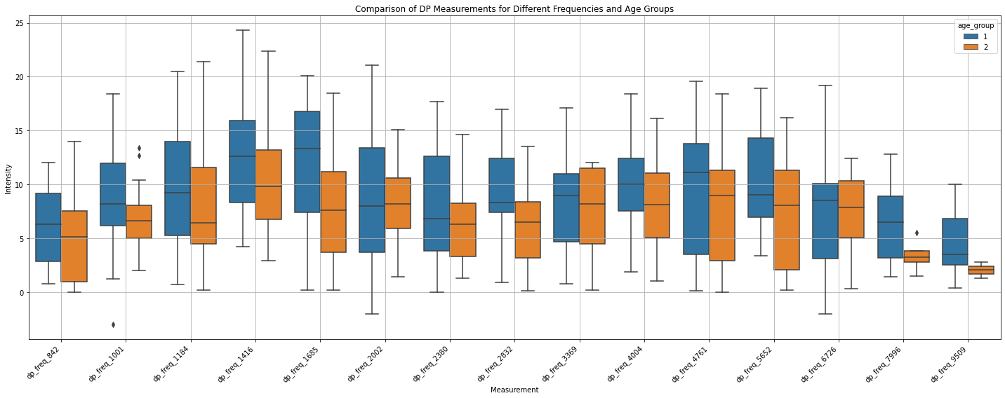

3. Boxplots to compare SNR measures for each age group at all frequencies:

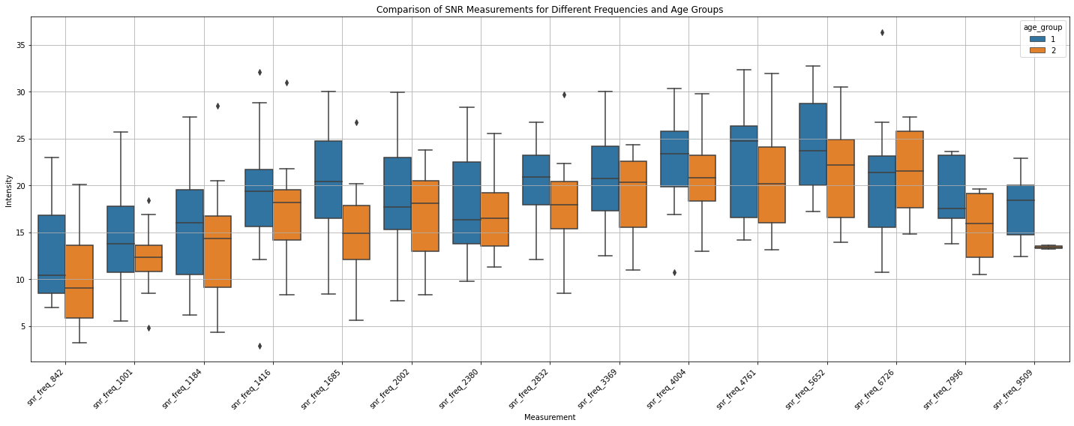

4. To check if the data are normally distributed. I conducted the checks separately since the DP and SNR data are different measurements. The first method used will be the histogram visualization method. The results are displayed in the plot below:
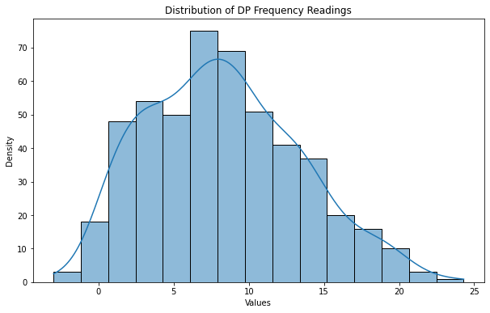
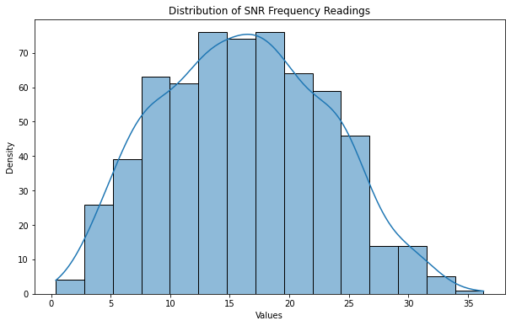

While the SNR data looks normally distributed, I can conduct the Shapiro-Wilk test to ascertain this. The result is shown in the table below:
 | P value (alpha = 0.05) | Interpretation
DP | 0.000008465313840133604 | Not normally distributed
SNR | 0.3677554726600647 | Normally distributed

To check if this is consistent within the age groups, the test was conducted to check the distribution of DP and SNR for each age group. The result is shown below:
 | Age Group | P value (alpha = 0.05) | Interpretation
DP | Group 1 | 0.003915222827345133 | NOT normally distributed
 | Group 2 | 0.0006874550599604845 | NOT Normally distributed
SNR | Group 1 | 0.3316843509674072 | Normally distributed
 | Group 2 | 0.6451948285102844 | Normally distributed

5. Statistical tests
a. I carried out inferential statistics to investigate the difference between the two age groups. I conducted a two-sample t-test to check if there is a significant difference between the mean of the two age groups for all DP and SNR frequencies measurements (i.e. the data has not been divided into specific frequencies). I also conducted the Mann Whitney U test for both. The results are shown below:

Test |  | P value (alpha = 0.05) | Interpretation
t-test | DP | 0.0002132974939930822 | Significant difference.
 | SNR | 0.000019729072110168965 | Significant difference.
MannWhitneyU | DP | 0.00047922483003939956 | Significant difference.
 | SNR | 0.00001305123232875918 | Significant difference.

b. Statistical tests for each frequency and age group. The Bonferroni correction has been applied, therefore, alpha = 0.033.
i. Mann Whitney U test for DP

Frequency | Stat | p-value (alpha = 0.033) | Interpretation
dp_freq_842 | 171.5 | 0.351328 | No significant difference.
dp_freq_1001 | 168.0 | 0.239900 | No significant difference.
dp_freq_1184 | 253.0 | 0.390191 | No significant difference.
dp_freq_1416 | 244.0 | 0.215965 | No significant difference.
dp_freq_1685 | 289.0 | 0.040589 | No significant difference.
dp_freq_2002 | 218.5 | 0.887888 | No significant difference.
dp_freq_2380 | 262.0 | 0.412527 | No significant difference.
dp_freq_2832 | 251.0 | 0.034496 | No significant difference.
dp_freq_3369 | 138.0 | 0.591149 | No significant difference.
dp_freq_4004 | 137.5 | 0.350889 | No significant difference.
dp_freq_4761 | 217.0 | 0.264463 | No significant difference.
dp_freq_5652 | 203.5 | 0.170881 | No significant difference.
dp_freq_6726 | 58.5 | 0.759412 | No significant difference.
dp_freq_7996 | 25.5 | 0.279426 | No significant difference.
dp_freq_9509 | 11.0 | 0.333333 | No significant difference.

ii. Mann Whitney U test for SNR

Frequency | Stat | p-value (alpha = 0.033) | Interpretation
snr_freq_842 | 192.0 | 0.101129 | No significant difference.
snr_freq_1001 | 155.5 | 0.270496 | No significant difference.
snr_freq_1184 | 267.0 | 0.225059 | No significant difference.
snr_freq_1416 | 240.0 | 0.259132 | No significant difference.
snr_freq_1685 | 319.5 | 0.004463 | No significant difference.
snr_freq_2002 | 234.0 | 0.590492 | No significant difference.
snr_freq_2380 | 249.5 | 0.607484 | No significant difference.
snr_freq_2832 | 244.0 | 0.056223 | No significant difference.
snr_freq_3369 | 153.0 | 0.265569 | No significant difference.
snr_freq_4004 | 131.5 | 0.490458 | No significant difference.
snr_freq_4761 | 219.5 | 0.234340 | No significant difference.
snr_freq_5652 | 181.0 | 0.156360 | No significant difference.
snr_freq_6726 | 54.5 | 0.581377 | No significant difference.
snr_freq_7996 | 26.0 | 0.260140 | No significant difference.
snr_freq_9509 | 12.0 | 0.222222 | No significant difference.

iii. Two sample t-test for DP

Frequency | Stat | p-value (alpha = 0.033) | Interpretation
dp_freq_842 | 0.814208 | 0.421544 | No significant difference.
dp_freq_1001 | 1.024766 | 0.313404 | No significant difference.
dp_freq_1184 | 0.996940 | 0.324787 | No significant difference.
dp_freq_1416 | 1.298921 | 0.201798 | No significant difference.
dp_freq_1685 | 2.201899 | 0.033654 | No significant difference.
dp_freq_2002 | 0.412378 | 0.682265 | No significant difference.
dp_freq_2380 | 1.049384 | 0.300148 | No significant difference.
dp_freq_2832 | 2.190105 | 0.035078 | No significant difference.
dp_freq_3369 | 0.614217 | 0.543702 | No significant difference.
dp_freq_4004 | 0.955768 | 0.347089 | No significant difference.
dp_freq_4761 | 0.960240 | 0.343340 | No significant difference.
dp_freq_5652 | 1.608477 | 0.116979 | No significant difference.
dp_freq_6726 | -0.056004 | 0.955845 | No significant difference.
dp_freq_7996 | 1.444120 | 0.176578 | No significant difference.
dp_freq_9509 | 1.022430 | 0.340606 | No significant difference

iv. Two sample t-test for SNR

Frequency | Stat | p-value (alpha = 0.033) | Interpretation
snr_freq_842 | 1.624533 | 0.114073 | No significant difference.
snr_freq_1001 | 1.371636 | 0.180349 | No significant difference.
snr_freq_1184 | 1.322938 | 0.193369 | No significant difference.
snr_freq_1416 | 0.978655 | 0.333940 | No significant difference.
snr_freq_1685 | 3.284957 | 0.002161 | Significant difference.
snr_freq_2002 | 0.759023 | 0.452289 | No significant difference.
snr_freq_2380 | 0.648509 | 0.520271 | No significant difference.
snr_freq_2832 | 1.772365 | 0.084797 | No significant difference.
snr_freq_3369 | 1.281826 | 0.209722 | No significant difference.
snr_freq_4004 | 0.714201 | 0.480812 | No significant difference.
snr_freq_4761 | 0.892626 | 0.377986 | No significant difference.
snr_freq_5652 | 1.588202 | 0.122074 | No significant difference.
snr_freq_6726 | -0.456058 | 0.652818 | No significant difference.
snr_freq_7996 | 1.439208 | 0.177934 | No significant difference.
snr_freq_9509 | 1.465497 | 0.186208 | No significant difference.
70 Left
1. Descriptive Statistics.
a. The descriptive data for all DP and SNR measurements (regardless of age group)

 | DP | SNR
Count | 483.000000 | 477.000000
Mean | 8.326915 | 17.651447
Std | 5.075924 | 6.293482
Min | 0.000000 | 0.140000
25% | 4.500000 | 13.400000
50% | 7.800000 | 17.300000
75% | 11.500000 | 22.400000
Max | 22.000000 | 33.800000

b. The descriptive statistics for all DP measurements for the age groups

 | Younger adults | Older Adults
Count | 8.000000 | 8.000000
Mean | 41.274096 | 33.849859
Std | 91.835282 | 73.452171
Min | 0.300000 | 0.000000
25% | 5.143361 | 4.641595
50% | 8.759142 | 7.538372
75% | 14.762500 | 13.325000
Max | 268.000000 | 215.000000

c. The descriptive statistics for all SNR measurements for the age groups

 | Younger adults | Older Adults
Count | 8.000000 | 8.000000
Mean | 46.976299 | 40.247503
Std | 87.483108 | 71.236322
Min | 0.140000 | 1.200000
25% | 11.841892 | 11.233320
50% | 18.251412 | 16.548372
75% | 26.000000 | 23.862500
Max | 262.000000 | 215.000000

2. Boxplots to compare DP measures for each age group at all frequencies:

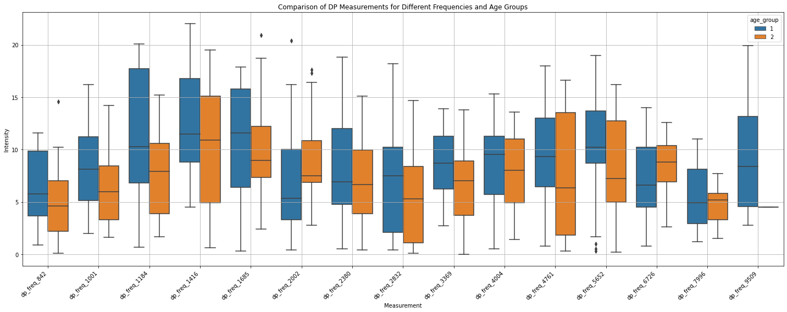

3. Boxplots to compare SNR measures for each age group at all frequencies:

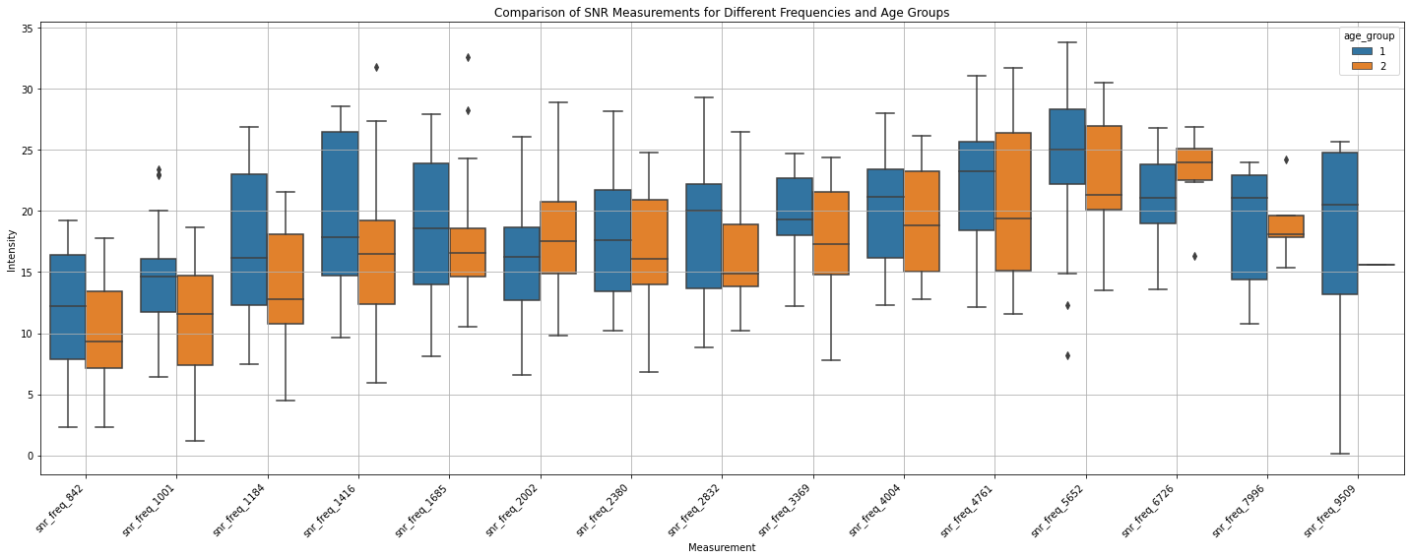

4. To check if the data are normally distributed. I conducted the checks separately since the DP and SNR data are different measurements. The first method used will be the histogram visualization method. The results are displayed in the plot below:

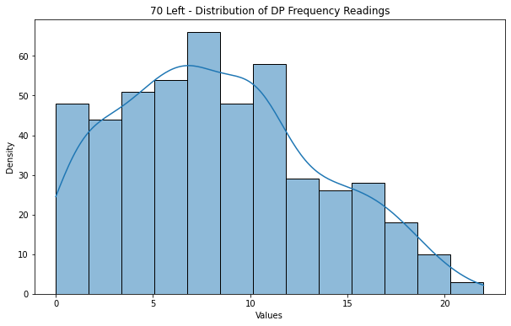

While the SNR data looks normally distributed, I can conduct the Shapiro-Wilk test to ascertain this. The result is shown in the table below:
 | P value (alpha = 0.05) | Interpretation
DP | 0.0000000430837374665316 | Not normally distributed
SNR | 0.05436358600854874 | Normally distributed

To check if this is consistent within the age groups, the test was conducted to check the distribution of DP and SNR for each age group. The result is shown below:
 | Age Group | P value (alpha = 0.05) | Interpretation
DP | Group 1 | 0.00001835893272073008 | NOT normally distributed
 | Group 2 | 0.0003288806474301964 | NOT Normally distributed
SNR | Group 1 | 0.06419827044010162 | Normally distributed
 | Group 2 | 0.5349607467651367 | Normally distributed
5. Statistical tests
a. I carried out inferential statistics to investigate the difference between the two age groups. I conducted a two-sample t-test to check if there is a significant difference between the mean of the two age groups for all DP and SNR frequencies measurements (i.e. the data has not been divided into specific frequencies). I also conducted the Mann Whitney U test for both. The results are shown below:

Test |  | P value (alpha = 0.05) | Interpretation
t-test | DP | 0.0327357135810374 | Significant difference.
 | SNR | 0.007082862491939675 | Significant difference.
MannWhitneyU | DP | 0.04933691945446292 | Significant difference.
 | SNR | 0.009098666380634975 | Significant difference.

b. Statistical tests for each frequency and age group. The Bonferroni correction has been applied, therefore, alpha = 0.033.

i. Mann Whitney U test for DP

Frequency | Stat | p-value (alpha = 0.033) | Interpretation
dp_freq_842 | 190.5 | 0.339355 | No significant difference.
dp_freq_1001 | 242.5 | 0.143914 | No significant difference.
dp_freq_1184 | 210.5 | 0.354926 | No significant difference.
dp_freq_1416 | 235.0 | 0.342979 | No significant difference.
dp_freq_1685 | 200.0 | 0.767288 | No significant difference.
dp_freq_2002 | 137.5 | 0.038873 | No significant difference.
dp_freq_2380 | 251.5 | 0.609009 | No significant difference.
dp_freq_2832 | 216.0 | 0.277294 | No significant difference.
dp_freq_3369 | 124.5 | 0.222124 | No significant difference.
dp_freq_4004 | 128.5 | 0.659553 | No significant difference.
dp_freq_4761 | 173.0 | 0.325438 | No significant difference.
dp_freq_5652 | 143.0 | 0.247656 | No significant difference.
dp_freq_6726 | 52.0 | 0.371093 | No significant difference.
dp_freq_7996 | 22.0 | 0.825728 | No significant difference.
dp_freq_9509 | 4.0 | 0.857143 | No significant difference.

ii. Mann Whitney U test for SNR

Frequency | Stat | p-value (alpha = 0.033) | Interpretation
snr_freq_842 | 197.5 | 0.238707 | No significant difference.
snr_freq_1001 | 252.0 | 0.083737 | No significant difference.
snr_freq_1184 | 233.5 | 0.109579 | No significant difference.
snr_freq_1416 | 247.5 | 0.198210 | No significant difference.
snr_freq_1685 | 208.0 | 0.602169 | No significant difference.
snr_freq_2002 | 174.5 | 0.256975 | No significant difference.
snr_freq_2380 | 241.0 | 0.798178 | No significant difference.
snr_freq_2832 | 222.5 | 0.201505 | No significant difference.
snr_freq_3369 | 115.0 | 0.253989 | No significant difference.
snr_freq_4004 | 121.0 | 0.675433 | No significant difference.
snr_freq_4761 | 158.0 | 0.438384 | No significant difference.
snr_freq_5652 | 136.0 | 0.383145 | No significant difference.
snr_freq_6726 | 30.0 | 0.040628 | No significant difference.
snr_freq_7996 | 17.0 | 1.000000 | No significant difference.
snr_freq_9509 | 3.0 | 1.000000 | No significant difference.

iii. Two sample t-test for DP

Frequency | Stat | p-value (alpha = 0.033) | Interpretation
dp_freq_842 | 0.919366 | 0.364381 | No significant difference.
dp_freq_1001 | 1.653100 | 0.106772 | No significant difference.
dp_freq_1184 | 1.223369 | 0.229138 | No significant difference.
dp_freq_1416 | 1.030578 | 0.309254 | No significant difference.
dp_freq_1685 | 0.206793 | 0.837305 | No significant difference.
dp_freq_2002 | -1.677019 | 0.101338 | No significant difference.
dp_freq_2380 | 0.681809 | 0.499193 | No significant difference.
dp_freq_2832 | 0.975195 | 0.335971 | No significant difference.
dp_freq_3369 | 1.404937 | 0.171876 | No significant difference.
dp_freq_4004 | 0.397721 | 0.693748 | No significant difference.
dp_freq_4761 | 1.002309 | 0.323714 | No significant difference.
dp_freq_5652 | 0.856039 | 0.398994 | No significant difference.
dp_freq_6726 | -0.933030 | 0.360932 | No significant difference.
dp_freq_7996 | 0.499682 | 0.627143 | No significant difference.
dp_freq_9509 | NaN | NaN | NaN

iv. Two sample t-test for SNR

Frequency | Stat | p-value (alpha = 0.033) | Interpretation
snr_freq_842 | 1.278273 | 0.209811 | No significant difference.
snr_freq_1001 | 2.255928 | 0.030075 | No significant difference.
snr_freq_1184 | 1.841883 | 0.073742 | No significant difference.
snr_freq_1416 | 1.574041 | 0.123768 | No significant difference.
snr_freq_1685 | 0.488282 | 0.628231 | No significant difference.
snr_freq_2002 | -1.227229 | 0.226910 | No significant difference.
snr_freq_2380 | 0.475761 | 0.636770 | No significant difference.
snr_freq_2832 | 1.438110 | 0.159040 | No significant difference.
snr_freq_3369 | 1.139795 | 0.265175 | No significant difference.
snr_freq_4004 | 0.552809 | 0.584781 | No significant difference.
snr_freq_4761 | 0.793518 | 0.433508 | No significant difference.
snr_freq_5652 | 0.602786 | 0.551336 | No significant difference.
snr_freq_6726 | -1.827420 | 0.081883 | No significant difference.
snr_freq_7996 | -0.146177 | 0.886686 | No significant difference.
snr_freq_9509 | NaN | NaN | NaN

65 Right
1. Descriptive Statistics.
a. The descriptive data for all DP and SNR measurements (regardless of age group)

 | DP | SNR
count | 433.000000 | 434.000000
mean | 7.611085 | 17.335484
std | 4.883951 | 6.000826
min | 0.000000 | 0.700000
25% | 3.700000 | 13.300000
50% | 7.200000 | 17.500000
75% | 10.800000 | 21.500000
max | 24.300000 | 34.700000

b. The descriptive statistics for all DP measurements for the age groups

 | Younger adults | Older Adults
count | 8.000000 | 8.000000
mean | 39.823296 | 28.456960
std | 88.046461 | 59.987210
min | 0.000000 | 0.000000
25% | 4.824214 | 4.090909
50% | 8.227043 | 6.338068
75% | 14.775000 | 12.493750
max | 257.000000 | 176.000000

c. The descriptive statistics for all SNR measurements for the age groups

 | Younger adults | Older Adults
count | 8.000000 | 8.000000
mean | 47.292644 | 34.482391
std | 85.245979 | 58.270351
min | 5.571110 | 0.700000
25% | 12.925000 | 10.201647
50% | 18.685019 | 15.376271
75% | 25.625000 | 22.000000
max | 257.000000 | 177.000000

2. Boxplots to compare DP measures for each age group at all frequencies:
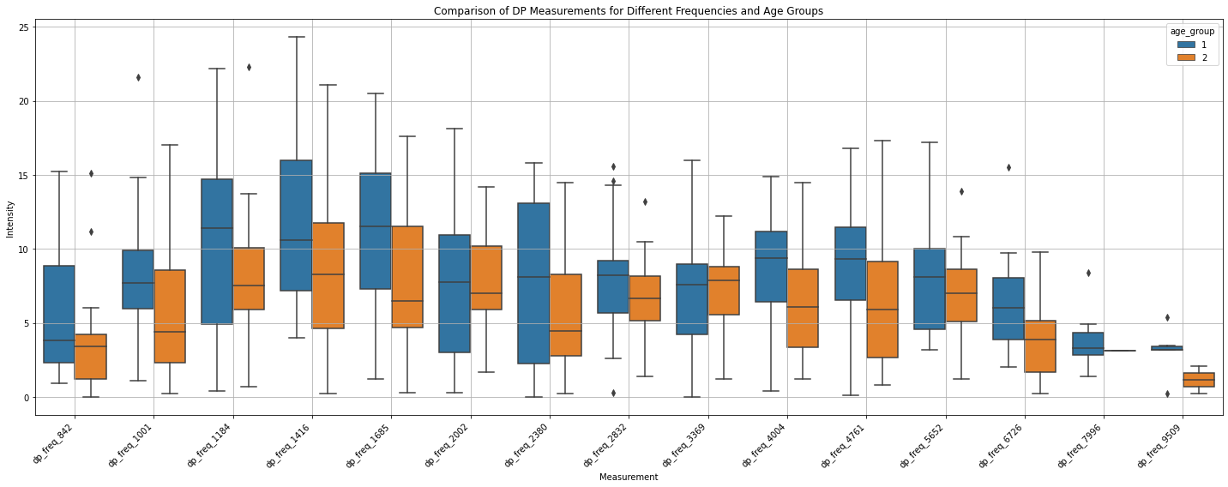

3. Boxplots to compare SNR measures for each age group at all frequencies:

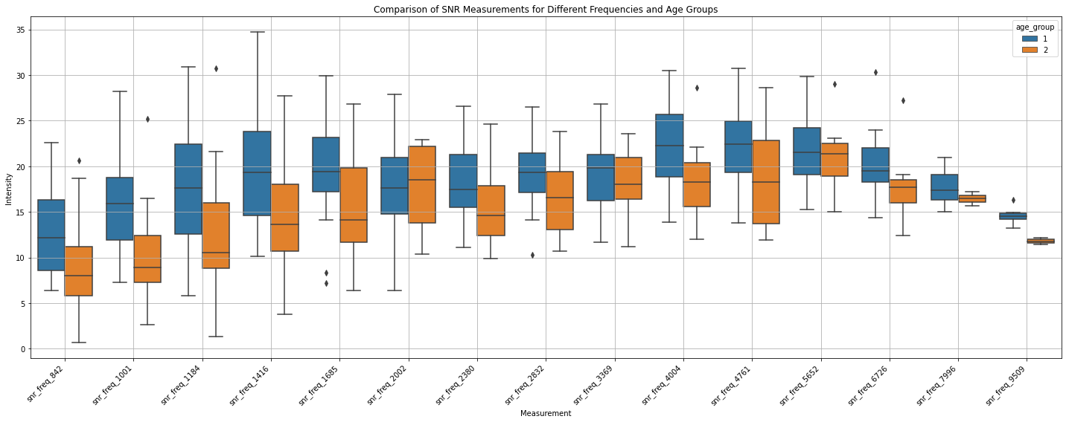

4. To check if the data are normally distributed. I conduct the checks separately since the DP and SNR data are different measurements. The first method used will be the histogram visualization method. The results are displayed in the plot below:
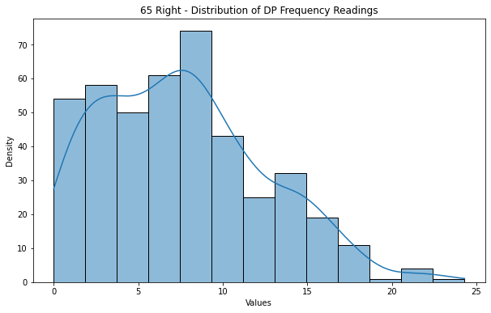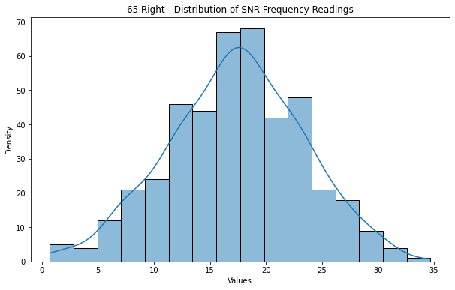

While the SNR data looks normally distributed, I can conduct the Shapiro-Wilk test to ascertain this. The result is shown in the table below:
 | P value (alpha = 0.05) | Interpretation
DP | 0.000000014560500360971673 | Not normally distributed
SNR | 0.5737723708152771 | Normally distributed

To check if this is consistent within the age groups, the test was conducted to check the distribution of DP and SNR for each age group. The result is shown below:
 | Age Group | P value (alpha = 0.05) | Interpretation
DP | Group 1 | 0.00008089374750852585 | NOT normally distributed
 | Group 2 | 0.000014519271644530818 | NOT Normally distributed
SNR | Group 1 | 0.3402734398841858 | Normally distributed
 | Group 2 | 0.6756279468536377 | Normally distributed

5. Statistical tests
a. I carried out inferential statistics to investigate the difference between the two age groups. I conducted a two-sample t-test to check if there is a significant difference between the mean of the two age groups for all DP and SNR frequencies measurements (i.e. the data has not been divided into specific frequencies). I also conducted the Mann Whitney U test for both. The results are shown below:

Test |  | P value (alpha = 0.05) | Interpretation
t-test | DP | 0.00011731917772615529 | Significant difference.
 | SNR | 0.0000000009285231235248957 | Significant difference.
MannWhitneyU | DP | 0.00017065842066016853 | Significant difference.
 | SNR | 0.000000005895869794689546 | Significant difference.

b. Statistical tests for each frequency and age group. The Bonferroni correction has been applied, therefore, alpha = 0.033.

i. Mann Whitney U test for DP

Frequency | Stat | p-value (alpha = 0.033) | Interpretation
dp_freq_842 | 160.0 | 0.167070 | No significant difference.
dp_freq_1001 | 223.0 | 0.046592 | No significant difference.
dp_freq_1184 | 197.5 | 0.260598 | No significant difference.
dp_freq_1416 | 273.0 | 0.047996 | No significant difference.
dp_freq_1685 | 240.0 | 0.034104 | No significant difference.
dp_freq_2002 | 145.5 | 0.945545 | No significant difference.
dp_freq_2380 | 179.5 | 0.371156 | No significant difference.
dp_freq_2832 | 143.5 | 0.239411 | No significant difference.
dp_freq_3369 | 88.0 | 0.814027 | No significant difference.
dp_freq_4004 | 145.5 | 0.081134 | No significant difference.
dp_freq_4761 | 154.5 | 0.104617 | No significant difference.
dp_freq_5652 | 99.0 | 0.522216 | No significant difference.
dp_freq_6726 | 54.0 | 0.173860 | No significant difference.
dp_freq_7996 | 4.5 | 0.826238 | No significant difference.
dp_freq_9509 | 10.5 | 0.169169 | No significant difference.

ii. Mann Whitney U test for SNR

Frequency | Stat | p-value (alpha = 0.033) | Interpretation
snr_freq_842 | 173.0 | 0.060047 | No significant difference.
snr_freq_1001 | 250.0 | 0.004382 | No significant difference.
snr_freq_1184 | 226.5 | 0.040956 | No significant difference.
snr_freq_1416 | 300.0 | 0.006735 | No significant difference.
snr_freq_1685 | 240.5 | 0.032888 | No significant difference.
snr_freq_2002 | 139.0 | 0.904875 | No significant difference.
snr_freq_2380 | 215.0 | 0.038464 | No significant difference.
snr_freq_2832 | 153.5 | 0.113655 | No significant difference.
snr_freq_3369 | 107.0 | 0.540741 | No significant difference.
snr_freq_4004 | 151.0 | 0.047690 | No significant difference.
snr_freq_4761 | 163.0 | 0.049168 | No significant difference.
snr_freq_5652 | 96.0 | 0.622777 | No significant difference.
snr_freq_6726 | 54.0 | 0.174083 | No significant difference.
snr_freq_7996 | 10.0 | 0.500000 | No significant difference.
snr_freq_9509 | 12.0 | 0.071429 | No significant difference.

iii. Two sample t-test for DP

Frequency | Stat | p-value (alpha = 0.033) | Interpretation
dp_freq_842 | 1.008832 | 0.321123 | No significant difference.
dp_freq_1001 | 1.924525 | 0.062690 | No significant difference.
dp_freq_1184 | 0.982317 | 0.332882 | No significant difference.
dp_freq_1416 | 2.111714 | 0.041343 | No significant difference.
dp_freq_1685 | 2.177368 | 0.036282 | No significant difference.
dp_freq_2002 | 0.379570 | 0.706697 | No significant difference.
dp_freq_2380 | 1.263909 | 0.215118 | No significant difference.
dp_freq_2832 | 1.068120 | 0.294277 | No significant difference.
dp_freq_3369 | -0.083169 | 0.934355 | No significant difference.
dp_freq_4004 | 1.674139 | 0.105240 | No significant difference.
dp_freq_4761 | 1.494658 | 0.145807 | No significant difference.
dp_freq_5652 | 0.656822 | 0.517068 | No significant difference.
dp_freq_6726 | 1.521823 | 0.147570 | No significant difference.
dp_freq_7996 | NaN | NaN | NaN
dp_freq_9509 | 1.489342 | 0.186975 | No significant difference.

iv. Two sample t-test for SNR

Frequency | Stat | p-value (alpha = 0.033) | Interpretation
snr_freq_842 | 1.977729 | 0.057209 | No significant difference.
snr_freq_1001 | 3.065031 | 0.004244 | No significant difference.
snr_freq_1184 | 1.917079 | 0.063662 | No significant difference.
snr_freq_1416 | 2.971534 | 0.005117 | No significant difference.
snr_freq_1685 | 2.339786 | 0.025126 | No significant difference.
snr_freq_2002 | -0.036302 | 0.971261 | No significant difference.
snr_freq_2380 | 2.243653 | 0.031684 | No significant difference.
snr_freq_2832 | 1.603557 | 0.119649 | No significant difference.
snr_freq_3369 | 0.452523 | 0.654646 | No significant difference.
snr_freq_4004 | 2.145493 | 0.040729 | No significant difference.
snr_freq_4761 | 2.220675 | 0.034344 | No significant difference.
snr_freq_5652 | 0.431379 | 0.669749 | No significant difference.
snr_freq_6726 | 1.127025 | 0.276351 | No significant difference.
snr_freq_7996 | 0.768746 | 0.467184 | No significant difference.
snr_freq_9509 | 3.562394 | 0.011893 | No significant difference.

65 Left
1. Descriptive Statistics.
a. The descriptive data for all DP and SNR measurements (regardless of age group)

 | DP | SNR
count | 402.000000 | 402.000000
mean | 7.500746 | 16.687562
std | 4.693862 | 5.289598
min | 0.000000 | 2.000000
25% | 4.000000 | 13.025000
50% | 6.700000 | 16.500000
75% | 10.800000 | 20.175000
max | 21.100000 | 31.400000

b. The descriptive statistics for all DP measurements for the age groups

 | Younger adults | Older Adults
count | 8.000000 | 8.000000
mean | 41.984437 | 21.004287
std | 95.569181 | 41.916183
min | 0.000000 | 0.000000
25% | 4.780321 | 3.643462
50% | 7.705036 | 6.067339
75% | 14.256250 | 10.506250
max | 278.000000 | 124.000000

c. The descriptive statistics for all SNR measurements for the age groups

 | Younger adults | Older Adults
count | 8.000000 | 8.000000
mean | 48.458349 | 26.704957
std | 93.193085 | 39.997726
min | 2.200000 | 2.000000
25% | 11.908244 | 9.721405
50% | 17.641906 | 14.302016
75% | 23.862500 | 19.475000
max | 278.000000 | 124.00000

2. Boxplots to compare DP measures for each age group at all frequencies:
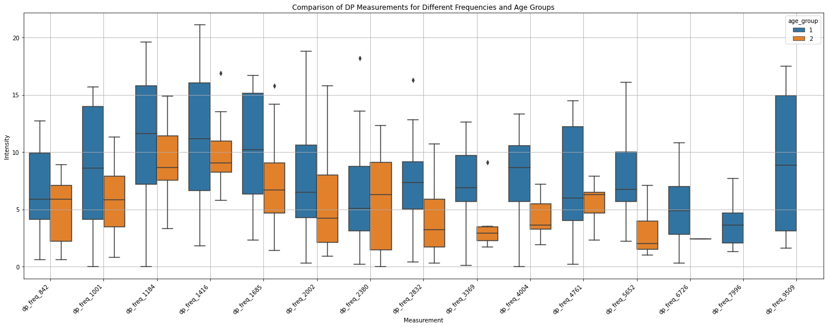

3. Boxplots to compare SNR measures for each age group at all frequencies:

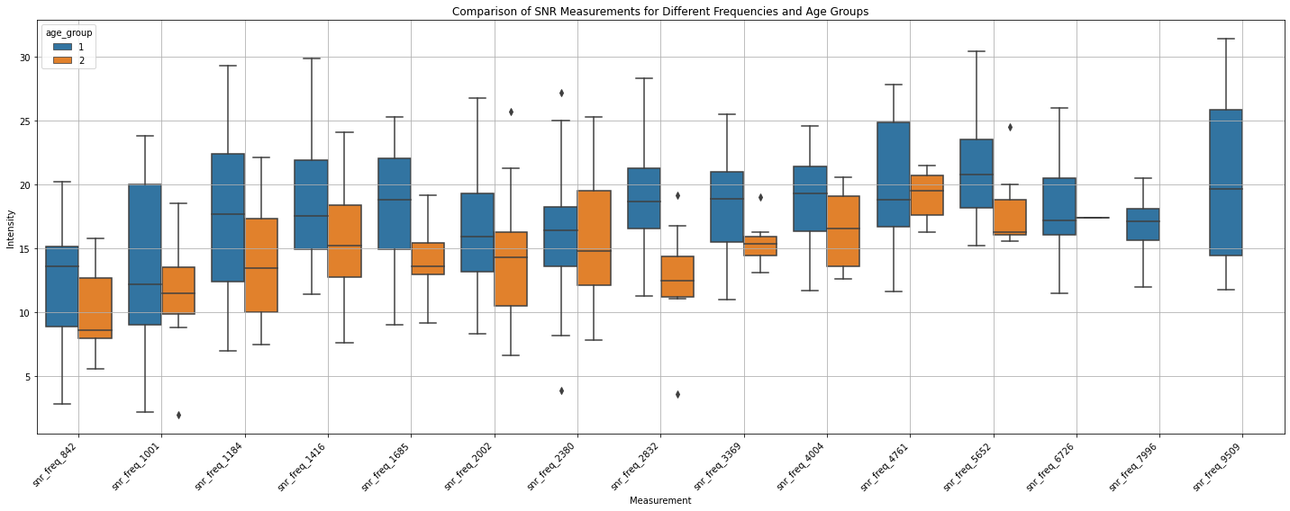

4. To check if the data are normally distributed. I conducted the checks separately since the DP and SNR data are different measurements. The first method used will be the histogram visualization method. The results are displayed in the plot below:

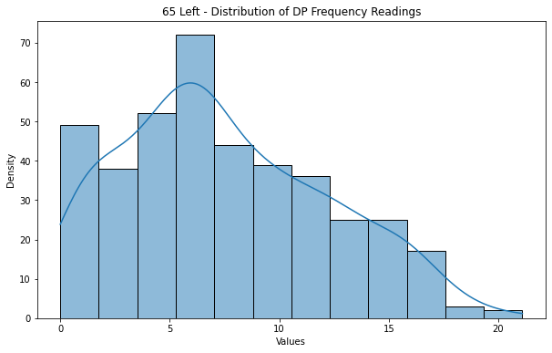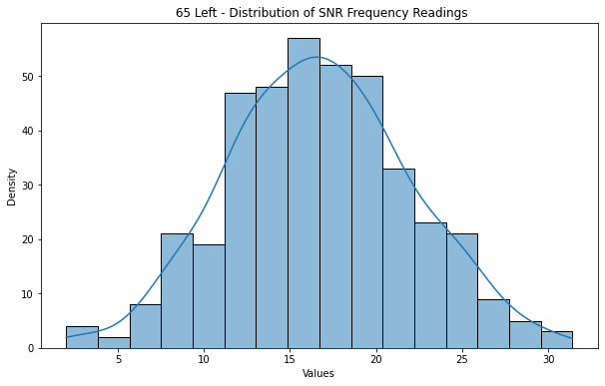

While the SNR data looks normally distributed, I can conduct the Shapiro-Wilk test to ascertain this. The result is shown in the table below:
 | P value (alpha = 0.05) | Interpretation
DP | 0.00000009624377383943283 | Not normally distributed
SNR | 0.8641867637634277 | Normally distributed

To check if this is consistent within the age groups, the test was conducted to check the distribution of DP and SNR for each age group. The result is shown below:
 | Age Group | P value (alpha = 0.05) | Interpretation
DP | Group 1 | 0.000030518345738528296 | NOT normally distributed
 | Group 2 | 0.0008732065325602889 | NOT Normally distributed
SNR | Group 1 | 0.9340571165084839 | Normally distributed
 | Group 2 | 0.9848800301551819 | Normally distributed

5. Statistical tests
a. I carried out inferential statistics to investigate the difference between the two age groups. I conducted a two-sample t-test to check if there is a significant difference between the mean of the two age groups for all DP and SNR frequencies measurements (i.e. the data has not been divided into specific frequencies). I also conducted the Mann Whitney U test for both. The results are shown below:

Test |  | P value (alpha = 0.05) | Interpretation
t-test | DP | 0.00008585500527970127 | Significant difference.
 | SNR | 0.000000008349113484345078 | Significant difference.
MannWhitneyU | DP | 0.000249341064862898 | Significant difference.
 | SNR | 0.000000007421808725107815 | Significant difference.

b. Statistical tests for each frequency and age group. The Bonferroni correction has been applied, therefore, alpha = 0.033.

i. Mann Whitney U test for DP

Frequency | Stat | p-value (alpha = 0.033) | Interpretation
dp_freq_842 | 110.5 | 0.345243 | No significant difference.
dp_freq_1001 | 137.0 | 0.183106 | No significant difference.
dp_freq_1184 | 160.5 | 0.203149 | No significant difference.
dp_freq_1416 | 202.0 | 0.310408 | No significant difference.
dp_freq_1685 | 252.5 | 0.037619 | No significant difference.
dp_freq_2002 | 216.0 | 0.199014 | No significant difference.
dp_freq_2380 | 136.5 | 0.886943 | No significant difference.
dp_freq_2832 | 130.5 | 0.055030 | No significant difference.
dp_freq_3369 | 96.0 | 0.022203 | No significant difference.
dp_freq_4004 | 81.5 | 0.071737 | No significant difference.
dp_freq_4761 | 84.0 | 0.595473 | No significant difference.
dp_freq_5652 | 123.5 | 0.003354 | No significant difference.
dp_freq_6726 | 13.0 | 0.555556 | No significant difference.
dp_freq_7996 | NaN | NaN | NaN
dp_freq_9509 | NaN | NaN | NaN

ii. Mann Whitney U test for SNR

Frequency | Stat | p-value (alpha = 0.033) | Interpretation
snr_freq_842 | 121.5 | 0.143820 | No significant difference.
snr_freq_1001 | 125.0 | 0.409736 | No significant difference.
snr_freq_1184 | 167.0 | 0.129570 | No significant difference.
snr_freq_1416 | 227.0 | 0.076663 | No significant difference.
snr_freq_1685 | 290.5 | 0.001490 | Significant difference.
snr_freq_2002 | 224.0 | 0.127659 | No significant difference.
snr_freq_2380 | 147.5 | 0.593929 | No significant difference.
snr_freq_2832 | 155.5 | 0.001825 | Significant difference.
snr_freq_3369 | 87.5 | 0.080584 | No significant difference.
snr_freq_4004 | 68.0 | 0.368016 | No significant difference.
snr_freq_4761 | 77.0 | 0.876470 | No significant difference.
snr_freq_5652 | 106.5 | 0.046324 | No significant difference.
dp_freq_6726 | NaN | NaN | NaN
dp_freq_7996 | NaN | NaN | NaN
dp_freq_9509 | NaN | NaN | NaN

iii. Two sample t-test for DP

Frequency | Stat | p-value (alpha = 0.033) | Interpretation
dp_freq_842 | 1.188183 | 0.245108 | No significant difference.
dp_freq_1001 | 1.437446 | 0.161295 | No significant difference.
dp_freq_1184 | 1.146426 | 0.260391 | No significant difference.
dp_freq_1416 | 1.114891 | 0.272285 | No significant difference.
dp_freq_1685 | 2.058987 | 0.046586 | No significant difference.
dp_freq_2002 | 1.166642 | 0.251025 | No significant difference.
dp_freq_2380 | 0.349738 | 0.728757 | No significant difference.
dp_freq_2832 | 2.104805 | 0.045125 | No significant difference.
dp_freq_3369 | 2.395565 | 0.025538 | No significant difference.
dp_freq_4004 | 1.848398 | 0.078032 | No significant difference.
dp_freq_4761 | 1.111144 | 0.276676 | No significant difference.
dp_freq_5652 | 3.411136 | 0.002205 | Significant difference.
dp_freq_6726 | NaN | NaN | NaN
dp_freq_7996 | NaN | NaN | NaN
dp_freq_9509 | NaN | NaN | NaN

iv. Two sample t-test for SNR

Frequency | Stat | p-value (alpha = 0.033) | Interpretation
snr_freq_842 | 1.429909 | 0.164214 | No significant difference.
snr_freq_1001 | 1.229888 | 0.228624 | No significant difference.
snr_freq_1184 | 1.790414 | 0.083159 | No significant difference.
snr_freq_1416 | 2.053887 | 0.047304 | No significant difference.
snr_freq_1685 | 3.454675 | 0.001398 | Significant difference.
snr_freq_2002 | 1.479496 | 0.147706 | No significant difference.
snr_freq_2380 | 0.476257 | 0.637029 | No significant difference.
snr_freq_2832 | 3.775655 | 0.000837 | Significant difference.
snr_freq_3369 | 1.774946 | 0.089746 | No significant difference.
snr_freq_4004 | 1.141752 | 0.265832 | No significant difference.
snr_freq_4761 | 0.373204 | 0.712022 | No significant difference.
snr_freq_5652 | 2.004259 | 0.055989 | No significant difference.
dp_freq_6726 | NaN | NaN | NaN
dp_freq_7996 | NaN | NaN | NaN
dp_freq_9509 | NaN | NaN | NaN

