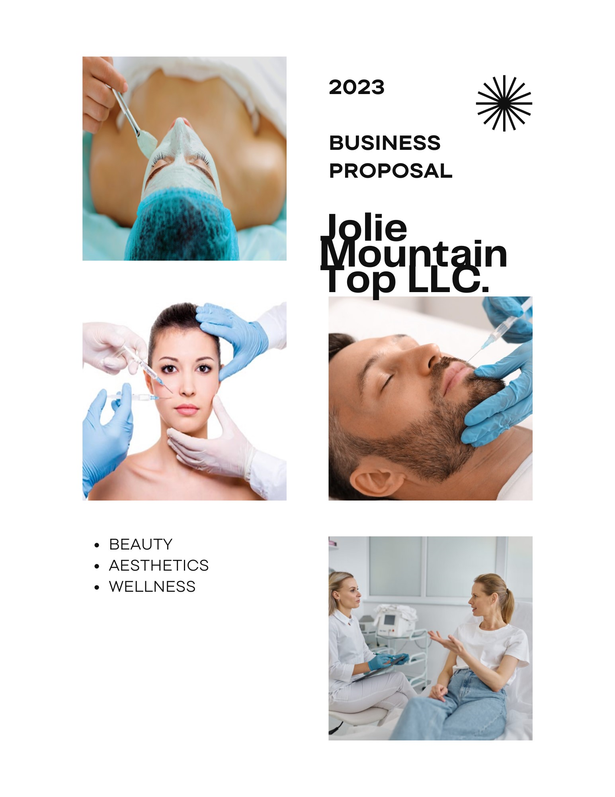
Non-Disclosure and Confidentiality Agreement
This Business Proposal (“Jolie Mountain Top”) contains certain information regarding the current and planned operations, and business of Jolie Mountain Top LLC., including the projected financial performance of the Company. Jolie Mountain Top LLC has provided this Business Proposal to the recipient solely for assisting the recipient in deciding whether to proceed with an in--depth investigation of the Company under procedures established by the Company and its advisors.
By accepting a copy of this Business Proposal, the recipient agrees, among other things, to keep the information contained herein confidential. The recipient agrees to restrict the use of any information contained herein to those within the recipient’s organization or designated representatives who understand the confidential nature of such information and need to have such information connected with the organization’s evaluation of the Company.
All Confidential Information shall remain the property of Jolie Mountain Top LLC. The recipient shall agree to retain the Confidential Information in strict confidence, to protect the security, integrity and confidentiality of such information and to not permit unauthorized access to or unauthorized use, disclosure, publication or dissemination of Confidential Information except in conformity with this Agreement. Also, recipient shall adopt and/or maintain security processes and procedures to safeguard the confidentiality of all Confidential Information provided by Jolie Mountain Top LLC using a reasonable degree of care, but not less than that degree of care used in safeguarding their own similar information or material.

CONTENTS
CONTACT INFORMATION 4
EXECUTIVE SUMMARY 5
BUSINESS DESCRIPTION 7
PRODUCTS AND SERVICES 8
MARKET ANALYSIS 10
SWOT ANALYSIS 14
MARKETING AND SALES STRATEGY 16
FUNDING REQUEST 18
FINANCIAL PROJECTIONS 18
CONCLUSION 20

CONTACT INFORMATION
- Entrepreneur: Leah Johnson

- Title: Owner

- Phone: 914.552.1699

- Email: Leahjohnson0502@gmail.com

- City: Tannersville

- Province or Territory: New York

- Zip/Postal Code: 12485

- Country: USA

- Country of Citizenship: USA

- Race or Ethnicity: White/Caucasian

EXECUTIVE SUMMARY
Jolie Aesthetics and Wellness is not just a spa; it is a sanctuary for beauty, wellness, and relaxation in the heart of a burgeoning tourist destination. Founded by skincare and beauty educator Leah Johnson, our vision is to be the premier destination for individuals seeking transformative beauty experiences and holistic wellness in the realms of tranquil mountain setting.
The Limitless Potential of Jolie Aesthetics and Wellness
Jolie Mountain Top is not just one of spas that offer a little extra, we want to be that go-to medical aesthetic clinic that help restore our clients’ self-confidence that had been subdued by embarrassing scars, improper facial structured that was either marred by accidents, birth defects or aging. As far as Jolie Mountain Top is concerned, beauty is not about conformity to societal standards, but a celebration of individuality. With this ideology, we are on the mission to provide a holistic approach to beauty, one that harmonized the inner and outer self.

Today the global medical aesthetics industry stands at 9.4 billion, and has cumulative growth rate of over 10%, which gives us an assumption of the industry would worth over $30 B (USD) by 2030.

That’s not just awesome, that’s the definition of a transformation made possible by medical aesthetics industry. In other words, entry into this industry is highly profitable. With a panoramic backdrop of natural beauty, our spa stands as a beacon of transformation and rejuvenation, serving a diverse clientele;
- The Local Community
- Weekend Homeowners - For those who own vacation homes in the area, Jolie becomes more than a spa; it's a vacation wellness oasis.
- Tourists
- Curated Beauty and Skincare Products.
Knowing that there is a limit to the class of people who can access this miracle medical intervention that can help them live up to their potentials, we offer to be the cost-effective solution for cosmetic medicine in New York. Our vision, mission and objectives are centered on giving our clients the best as long as it is medically safe. No matter what we do for our clients, their health comes first. As such, our environments, equipment, procedure will be safe, welcoming and relaxing.

Marketing Highlights
Our marketing approach includes:
- Focus on digital marketing: we will be represented across all social media platform with a major aim of building a community of our customers
- Offline marketing which includes advertising, printing of flyers and giving each and every client a pleasurable moment in our clinic, no matter what they come in for
Our major marketing goals are:
- Becoming 1st choice for a medical spa experience in the whole Tannersville area.
- Earning at least 500% ROI on our digital marketing efforts
- Maintaining at least 90% retention of customers by offering personalized services in follow up calls and CRM
- 50% increase in organic traffic

Financial Highlights
In the end Jolie Mountain Top is more focused on long term goals and profitability. This is because our choice of pricing is such that will bring a long term benefit. To make our long term dreams come to reality, we will require funding of Jolie Mountain Top with $50,000.

0
0.5
1
1.5
2
2.5
3
3.5
4
4.5
5
Year 1
Year 2
Year 3
Chart Title
Expenses
Income
Income after Taxes

BUSINESS DESCRIP TION
About Leah Johnson
She is the CEO of Jolie Mountain Top. She is a visionary in beauty and wellness. A true luminary with an unwavering commitment to transforming not just the way people perceive their own beauty, but also how they experience it. Her story is one of passion, knowledge, and a profound dedication to her craft.
Her path was not a conventional one. She didn't merely aim to provide services; she yearned to educate and empower others in the world of beauty and wellness. With this vision in mind, she pursued extensive education and training. Leah knew that to make a meaningful impact, she had to equip herself with not just the skills but the knowledge to educate others.
Over the years, Leah's journey took her through prestigious institutions, advanced courses, and mentorships with industry experts. She devoured every piece of information, each new technique, and every scientific advancement. But what set Leah apart was her unquenchable thirst for knowledge and her ability to distill complex information into accessible wisdom.
The creation of Jolie Aesthetics and Wellness was a turning point in Leah's journey. She envisioned it as a sanctuary, a place where beauty and wellness intertwined to nurture not just the body, but also the spirit. Leah's journey also emphasized sustainability and eco-friendliness. In an industry where excessive waste is the norm, she chose a different path. Her spa incorporated sustainable practices, making it not just a place of beauty but also a place of responsibility. This decision echoed her belief in a holistic approach to beauty, one that extended to the planet itself.
Company History: Jolie Mountain Top, LLC, founded in April 2022 and later rebranded in 2023, emerged from the collaboration between Leah Johnson, a seasoned skincare and beauty retail educator, and Jolie Aesthetics and Wellness. The desire to bridge the gap in the local beauty and wellness landscape led to the inception of this female-owned and operated establishment. Grounded in the belief of beauty from the inside out, our journey began with a commitment to offering a haven where clients can escape, rejuvenate, and embrace their natural beauty.
Mission Statement: Jolie Mountain Top is dedicated to being the epitome of rejuvenation and empowerment in the heart of Tannersville. Our mission is to provide a sanctuary where clients experience a harmonious blend of cutting-edge medical aesthetics, curated skincare rituals, and personalized beauty. We strive to enhance natural features, promote mental and emotional wellbeing, and contribute to the vitality of the local community.
Vision Statement: Our long-term vision is to establish Jolie Mountain Top as a beacon of beauty and wellness, not just within Tannersville but as a destination renowned for its transformative spa experiences. We aspire to continually evolve, incorporating the latest advancements in medical aesthetics, fostering a culture of self-love, and being a driving force behind the economic growth and vibrancy of the community.
PRODUCTS AND SERVICES
Jolie Mountain Top offers to provide a world class aesthetic services in New York. Our clinic will be characterized by a clean, safe, world-equipped and a serene environment that not only nourishes your sight, but also relaxes every part of your muscles. Since our focus is entirely on cosmetic appearances, we shall be devoted to helping every patient fulfill their desire for a clearer skin, lighter tone and a better general outlook.
With a wealth of experience and a practicing license in New York, we are qualified to diagnose and provide treatment for skin problems or conditions are outside but in close relationship with our cosmetic services. While we do not offer surgical services, we are dermatologists who specializes in giving recreating the better of each client that walks through our door.
We are here for those who understand the importance of having a medical professional give them that face lift, instead of allowing just anyone make experiments with their faces. We offer a non-invasive procedures for face lifting and feature enhancements. Some of the common services we render are:
- Botulinum toxin injections (Botox) to help reduce client’s wrinkles
- Deep facial cleansing and exfoliation. Sometimes, we use Hydra facials to hydrate a dehydrated looking face
- Dermal fillers gel or injection, so as to soften creases and generally enhance the features of the face
- Laser hair remover targeted at permeating hair follicle in order to permanently get rid of hair roots
- Microdermabrasion which helps is getting rid of the outer skin layer, so as to promote a new skin cell growth
USP
Jolie Mountain Top's unique selling proposition is its holistic approach to beauty and wellness, which includes comprehensive services, educational empowerment, curated beauty products, and a commitment to sustainability. It goes beyond the ordinary spa experience to offer clients a transformative journey that celebrates inner harmony and well-being, making it a truly exceptional destination for those seeking more than just traditional beauty treatments.

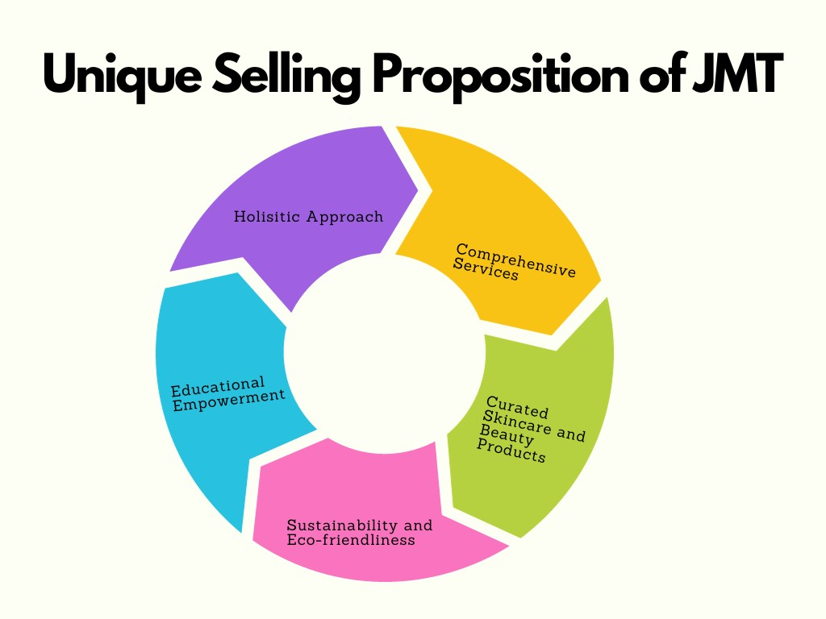
The Unique Selling Proposition (USP) of Jolie Mountain Top is its distinctive approach to beauty and wellness, setting it apart from other spas and medical aesthetics centers.

MARKET ANALYSIS
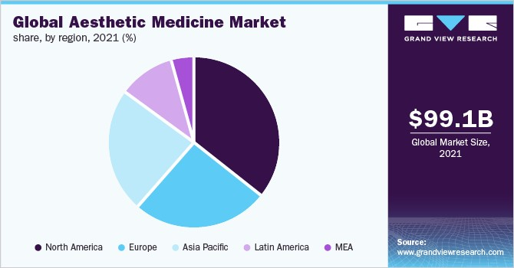
The global medical aesthetic devices market is projected to grow at an annual rate of 11.1% from 2022 to 2030, reaching an estimated USD 34.54 billion in 2030. The global aesthetic medicine market was valued at USD 16.5 billion in 2022 and is expected to expand at a compound annual growth rate (CAGR) of 18.5% from 2023 to 2032. Minimally or noninvasive medical aesthetics treatments increased by 10% between 2017 and 2018 and have increased nearly 200% since 2000.

Factors That Drive the Industry
Invasive procedures include liposuction, breast augmentation, and nose reshaping, and orthodontic dentistry and hair transplants are some of the most popular aesthetic procedures in high demand. The growing focus on physical appearance has increased the appeal of these invasive procedures. Some of the factors responsible for driving this industry are:

1. An Aging Population
The World Health Organization estimates that by 2030, 1 in 6 people worldwide will be aged 60 years or over, and this market segment is known for its disposable income. The relevant markets are Japan, China, the EU, and other wealthy countries where the over-60 population is much higher (Japan and South Korea: 1 in 3 people; China: 1 in 5 people; the EU: 1 in 5 people).

2. Social Media Influence
The widespread use of social media has transformed not only the way we communicate but also how we interact and view ourselves. The so-called selfie culture and the increased desire to look good on social media accounts have become major drivers for invasive and noninvasive aesthetic procedures.
Simultaneously, sophisticated personalized advertising platforms and more open communication about medical aesthetics treatments, have contributed to increased awareness and a more positive view of cosmetic procedures, even at a younger age.

3. Growing Demand for Low-Cost Aesthetic Medicine
The advancement of minimally invasive and noninvasive aesthetic procedures is fueling the increasing demand for noninvasive procedures. Furthermore, clients of aesthetic procedures are cash-paying customers, and the service providers love the fact that they don’t have to deal with insurance reimbursements.

4. Vanishing Taboos
Tattoos and sexual rejuvenation treatments are two things that no longer have any negative connotations. The tattoo industry is now a $3 billion per year business. We are currently seeing more people with tattoos than without, and it seems inevitable that the tattoo removal business will grow at an even higher rate. Currently, treatments leverage a variety of laser technologies with new solutions in advanced stages of development.
The availability of nonsurgical options for treating menopausal symptoms, incontinence, sexual function, rejuvenation, and performance issues for both men and women are among the latest growth trends in the industry. These treatments along with male enhancement procedures and cosmetic breast reconstruction have spread around the world, even to places where women are looked down upon and sexuality is looked down upon. Many of these treatments are based on platelet-rich plasma (PRP) delivery by electroporation.

5. Innovation Dynamics in the Medical Aesthetics Industry
The high-end device market is dominated by a few behemoth, serial-merged Wall Street players, but it is the innovative startups that garner buzz and attention at industry conferences and events, often leading to potential mergers with key market leaders that have the deep pockets necessary for market entry.
Invariably, a scientist or innovator picks up the challenge of building a feasibility model for the physician to try, and at this stage, they apply for patents. This modus operandi is a powerful innovation driver: Inventors and people who break new ground should focus on an early buyout or merger. They can develop technology and methods quickly on a small budget, which is something the global player who buys them can’t do.
Almost all new treatments follow this pattern, and it is usually the doctors who are researching the treatment who define and improve the protocol and bring it to the attention of the leaders in the field.

Relevance of the Industry Analysis
The above analysis has shown that:
- The industry will continue to witness a perpetual growth because of the aging population, the influx of young people who want to always look their best, and the innovation in the practice itself that makes for affordable solutions.
- There is free entry and exit of the industry; the competition will be massive in the nearest future
- Northern America accounts for the highest number of people patronizing aesthetic services.
- The industry is highly profitable
- The narratives about the type of persons who can afford medical aesthetic services is about to change soon
- The best time to enter the market is now, in order to take advantage of the babyhood stage of the industry
Market Trends:
- Rise in Medical Aesthetics: Increasing acceptance of non-invasive cosmetic procedures.
- Holistic Wellness: Growing demand for naturopathic medicine and holistic beauty.
- Localized Services: Preference for convenient, high-quality services within the community.
- Digital Presence: Emphasis on social media and online platforms for beauty and wellness promotion.
Target Market: Our ideal customers encompass three primary segments:
- Local Residents: Seeking accessible beauty services without the need to travel.
- Weekend Homeowners: Desiring vacation wellness experiences in the local area.
- Tourists: Exploring the mountain for recreational activities and seeking convenient beauty and skincare services.

SWOT Analysis
Strengths:
- Comprehensive Services: Jolie Mountain Top stands out with a diverse range of services, offering injectables, advanced skincare treatments, and holistic wellness practices. This comprehensive approach positions us as a one-stop destination for all beauty and wellness needs.
- Strategic Location: Nestled in Tannersville, our spa benefits from a strategic location that caters to both the local community and the influx of tourists. Proximity becomes a key strength, making our services easily accessible and convenient.
- Partnership with Jolie Aesthetics & Wellness: The collaboration with Jolie Aesthetics & Wellness not only enhances our service portfolio but also brings credibility and expertise. The partnership establishes a foundation for a holistic and reputable brand.
Weaknesses:
- Limited Brand Recognition: As a relatively new establishment, building brand awareness is a current challenge. Investing in targeted marketing campaigns and community engagement will be crucial to overcoming this weakness.
- Initial Dependency on Owner: The business currently relies on the owner for key functions. Developing a robust organizational structure and hiring skilled personnel will be essential to reduce dependency and ensure long-term sustainability.
Opportunities:
- Growing Tourism in Tannersville: With Tannersville becoming a burgeoning tourist destination, there is an opportunity to tap into a broader customer base. Tailoring services and marketing efforts to cater to tourists can be a lucrative avenue for growth.
- Local Development Initiatives: The recent downtown revitalization grant offers an opportunity to align with local development initiatives. Jolie Mountain Top can actively contribute to the community's economic growth and become an integral part of the revitalized downtown area.
- Untapped Market for Comprehensive Aesthetics Services: The absence of a full-service medical aesthetics practice in the immediate vicinity creates a significant market gap. Jolie Mountain Top has the opportunity to establish itself as the go-to destination for comprehensive aesthetics services in the region.
Threats:
- Competition from Nearby Medispas: The proximity of Medispas in Kingston poses a competitive threat. To counter this, emphasizing the convenience of our location, unique service offerings, and competitive pricing will be crucial.
- Economic Uncertainties: Economic fluctuations can impact consumer spending on luxury services. A dynamic pricing strategy and diversified service offerings can mitigate the impact of economic uncertainties.
- Changing Consumer Preferences: Evolving trends and preferences in beauty and wellness pose a threat. Staying attuned to market dynamics, regularly updating services, and incorporating client feedback will be vital in adapting to changing consumer preferences.
In navigating this landscape, our SWOT analysis becomes a compass, guiding us through the terrain of strengths, weaknesses, opportunities, and threats. With a clear understanding of our position, Jolie Mountain Top is poised to not only meet but exceed the expectations of a community eager for a transformative and comprehensive beauty and wellness experience.

MARKETING AND SALES STRATEGY
Marketing and Sales Goal:
- Increase brand recognition and awareness among our target audience, measured by metrics such as website traffic, social media reach, and brand mentions.

- Generate a specified number of high-quality leads per month through various marketing channels, such as content marketing, social media, and email marketing.

- Improve the conversion rate of website visitors to leads or trial users by a certain percentage through optimized landing pages and compelling calls-to-action.

- Achieve 200% return on investment (ROI) for marketing activities for the first year. Subsequently, we hope to double efforts in the coming years. 200% ROI on the first year, 400% ROI on the second year

- Improve the conversion rate of leads into paying customers by optimizing the sales process and addressing customer pain points effectively.
Marketing Channels

Website and Blog: Establish a professional and informative website that showcases your SaaS innovation's features, benefits, and success stories. Regularly update the blog with valuable content addressing industry trends, use cases, and best practices.
Social Media Platforms: Leverage LinkedIn, Twitter, Facebook, Instagram, and YouTube to engage with your target audience. Share blog posts, videos, infographics, and customer testimonials to build brand awareness and drive traffic to your website.
Paid Advertising: Utilize Google Ads and social media advertising (e.g., Facebook Ads, LinkedIn Sponsored Content) to reach a broader audience. Set up targeted campaigns based on demographics, interests, and keywords to drive lead generation.
We will continually evaluate campaign performance, track key metrics, and make data-driven adjustments to optimize our marketing efforts. Consistency and integration across various marketing channels and messaging will strengthen our brand presence and foster long-term relationships with our audiences.
Pricing Strategy:
Competitive and Accessible Pricing: Our pricing strategy aims to strike a balance between competitiveness and accessibility. While offering premium services, we will ensure that our pricing is in line with market standards. This approach caters to the diverse needs of both local residents and visitors seeking luxury spa experiences.
Dynamic Pricing for Tourists: Recognizing the seasonal nature of tourist traffic, dynamic pricing strategies will be employed during peak tourist seasons. This flexibility allows us to capitalize on increased demand and adjust prices accordingly.
Membership Programs: Introducing membership programs will foster customer loyalty and provide exclusive benefits such as discounted services, early access to promotions, and personalized skincare consultations. This tiered approach encourages recurring revenue and long-term relationships with our clients.

FUNDING REQUEST
Amount Requested: Jolie Mountain Top seeks a grant in the amount of $50,000 to support the initial startup costs and the renovation of our dedicated space in Tannersville, New York. This funding will play a pivotal role in bringing our vision to life, establishing a state-of-the-art spa facility that aligns with our commitment to providing exceptional beauty and wellness services.
Use of Funds: The grant funds will be allocated to cover critical components of the startup and renovation process, ensuring a seamless and inviting environment for our clients. The breakdown of fund utilization is as follows:
- Construction and Design: ($20,000)
  - Renovation of the designated space to meet the aesthetic and functional requirements of a modern and luxurious spa.
  - Implementation of design elements that create a serene and welcoming ambiance, contributing to an elevated client experience.
- Décor and Furnishing: ($10,000)
  - Procurement of high-quality furnishings and décor items to enhance the overall aesthetic appeal of the spa.
  - Investment in comfortable and stylish furniture that complements the spa’s theme, fostering a relaxing environment for clients.
- Equipment and Technology: ($20,000)
  - Acquisition of state-of-the-art equipment necessary for delivering top-notch medical aesthetics services, ensuring the highest standards of safety and effectiveness.
  - Integration of technology solutions that enhance operational efficiency and client experience.
The judicious use of the grant funds in these key areas will lay the foundation for Jolie Mountain Top’s success, enabling us to create a spa facility that not only meets but exceeds the expectations of our diverse clientele. We are committed to transparent and responsible financial management, ensuring that each dollar invested contributes to the growth and sustainability of our business.

FINANCIAL PROJECTIONS
Revenue Assumption
Our revenue generation is based on the following:
- Cost of the least service offered by JMT is $200
- Right now we have about 50 person client base monthly
- We can make at least $10,000 in a month to be doubled every three months with our aggressive marketing effort, and that will make a total of $450,000 at the end of the first year
JMT is able to retain profits throughout the forecast period because we have been doing business for a while now and we already have a solid clientele of over 200. Performance during the first year will be optimal; however, the company will generate lucrative profits as we gain market recognition. The revenue is expected to grow, indicating a healthy cash position and robust business model.

Income Statements (Projected Profit and Loss):
Year | Revenue | Operating Expenses | Gross Profit | 20% Taxes | Net Profit | % Profit
Year 1 | $450,000 | $100,000 | $350,000 | $70,000 | $280,000 | 280%
Year 2 | $900,000 | $150,000 | $750,000 | $150,000 | $600,000 | 400%
Year 3 | $1,800,000 | $200,000 | $1,600,000 | $320,000 | $1,280,000 | 640%

Cash Flow Statements (Projected):
Year | Cash Inflow | Cash Outflow | Net Cash Flow
Year 1 | $450,000 | $100,000 | $350,000
Year 2 | $900,000 | $150,000 | $600,000
Year 3 | $1,800,000 | $200,000 | $1,600,000

Balance Sheets (Projected):
 | Total Assets | Owner’s Equity | Total Liabilities
Year 1 | $500,000 | $60,000 | $560,000
Year 2 | $1,100,000 | $400,000 | $1,500,000
Year 3 | $1,950,000 | $1,150,000 | $3,100,000

Break-even Analysis:
Most businesses have their break-even by the second year, interestingly for Jolie Mountain Top, and taking only the least worth of service into consideration, we will break-even by the first year of operation. This calculation takes into account fixed costs, variable costs per unit, and the anticipated average revenue per unit. As we grow, the margin of safety increases, ensuring a more resilient and profitable business model.
These financial projections are based on reasonable assumptions and industry benchmarks. Even in the face a dynamic market conditions and operational factors, this business is bound to make profit. The outlined projections provide a roadmap for sustainable growth, with a focus on achieving profitability and positive cash flow.

CONCLUSION
In conclusion, Jolie Mountain Top is not merely a business; it's a vision manifested. A vision of beauty that transcends the superficial, wellness that goes beyond the physical, and a community uplifted by the spirit of rejuvenation. With your support, we look forward to turning this vision into reality and making Jolie Mountain Top a destination cherished by locals and visitors alike.

